This offers hopes': 16-year-old ministry has helped thousands in county
Suzanne Nolan Wisler
The Monroe News
November 22, 2023

MONROE — When she entered the old powerhouse building at the Sisters, Servants of the Immaculate Heart of Mary Motherhouse, Rebecca McGlynn of Maybee needed a couch, dining room table and chairs, a rug, towels and bedding for her family of seven. She left with all of it, even a large sectional sofa that fits her whole family.

“This is amazing,” said McGlynn, as volunteers loaded up her truck. McGlynn was a recent client of Monroe’s In the Spirit of Giving ministry. Donated household items and furniture are given for free to Monroe County residents who need assistance. All recipients are vetted by a local agency, such as Monroe County Opportunity Program and Recovery Advocacy Warriors. Some of them are homeless. Others have financial needs or illnesses. Some have just been released from jail.

In its 16 years, organizer and volunteer Lori Bronson said the ministry has helped many thousands of Monroe County families. Clients get an appointment to work one-on-one with a volunteer. The schedule is booked for weeks.

McGlynn and her husband, Matthew, have five children. She has health problems and has had 13 surgeries so far. Her health has left her unable to work. With a large family and only one income, McGlynn said the bills are piling up. Their children are 7, 9, 11 and 17; the oldest is an adult.

McGlynn had never heard of In the Spirt of Giving, but was referred by MCOP. “I asked a lot of questions,” she said. At the Motherhouse, McGlynn was given a shopping cart and help from Gwen Marlow of Carleton, a volunteer since the ministry began in 2007.

Armed with McGlynn’s list of needs, the pair walked among the shelves. An entire area in the powerhouse building holds bedding in all sizes. Mattresses and large rugs fill the back wall. Another section contains kitchen supplies, like place settings, cups and spatulas. There’s an area filled with wooden tables and furniture. “My daughter will love this,” said McGlynn as she put a set of gray and white sheets into her cart.

“We don’t have a dining room table,” she said. Soon, she found a wooden table and chairs. She also chose a large rug to replace the carpeting the family just removed.

When her checklist was complete, volunteers and McGlynn loaded her truck to capacity. She even had to return for a second load. “I’m very grateful,” McGlynn said.

In the Spirit of Giving
An ill child was the inspiration for the In the Spirit of Giving ministry. In 2007, Bronson was director of religious education for Monroe's St. Mary Catholic Church. For the Feast of the Our Lady of Guadalupe, she offered a program for families. The speaker was Jeff Weaver, founder of the God Works food ministry. “He said there was a family with a 12-year-old son with a brain tumor,” Bronson said. “His parents sold their home, trying to provide.”

The family was able to get a house through a grant from the Salvation Army, but they had no furnishings. Bronson requested the religious education families donate household items.
“It’s our faith. There’s more we could do,” she said.

Donations poured in, much more than one family could use. So, Bronson and the Monroe Catholic Vicariate Peace and Justice Committee decided to help more families. They stored and distributed donations at the former brother house at St. Mary Catholic Central High School. Then, the pipes burst.

So, they moved to the gym at the former St. Mary Academy, even though the gym had no heat, light or water. “We had a lot of space there. We wore hats and gloves in the winter,” Bronson said. When the Sisters became concerned about the gym’s air quality, the ministry moved to its current space at the IHM Motherhouse. “We are very grateful to the Sisters,” Bronson said.

The powerhouse building has lights, heat and water, even a bathroom, but it’s also 1,000 feet smaller than the previous location. Sometimes, when donations are plentiful, Bronson stores them in her own garage.

The donations
The household items and furniture offered by In the Spirit of Giving are all donated by area residents. Some come from estates or after spring or fall cleaning. Other items come from businesses and organizations. The Scrappy Quilters at Bedford Senior Center, for example, recently donated handmade quilts. Walmart provided shopping carts. Bronson said holidays always bring a lull in donations, but demand is always great, especially for couches and beds.

“Beds are a big thing. There is a great need for beds in the county. Some are sleeping on the floor,” Bronson said. All items must be in good shape and be free from heavy stains.
“They need to have some life left,” Bronson said.

On the day McGlynn visited the ministry, so did Ileene Smith of Monroe. She donated pillows, a table and a couple boxes of kitchenware.

Smith and her husband, Larry, are downsizing from a 3,000-foot house to 1,900 feet.
“We don’t need all this. Someone else can use it. We have no room for all this extra stuff,” Smith said.

The volunteers
A handful of volunteers work at the two-day-a-week ministry with Bronson. Some, like Gwen Marlow, have been with the ministry since it began. Bill Ziegler of Monroe began volunteering about four years ago. Among his jobs is repairing chips and nicks in wooden tables. Recently Ziegler completely refinished two tables. He cleans all the wood with his bottle of wood polish.

“I enjoy it,” Ziegler said. “You have to do it because you like it.” The retired Chrysler employee said he can empathize with the clients. “As a kid in the 1940s, the Salvation Army was our favorite store,” he said. “I’ve been there. I have to be there for others.”

Volunteer Matt Miller of Monroe came to In the Spirit of Giving in 2015. He’s a member of St. Mary Catholic Church. Miller said he does whatever is needed, including moving heavy items and picking up donations from donors’ homes. “I help people bring in the stuff,” Miller said.

The recipients
Adult clients of In the Spirit of Giving come from all ages and backgrounds. Bronson said the oldest have been in their 80s. She said need is great in this area now, and she’s not sure why. “We got some with the tornado in Frenchtown (Aug. 25),” Bronson said. Other clients, she said, “were in prison, had a flood or disaster. Some have difficulty coping with life. Many have illnesses.”

Bronson said most clients are respectful and extremely grateful. “We tell them, 'All of this was donated. Take just what you need.' They get it,” she said. “They are like a kid in a candy store or on Christmas. This offers hope.” “We had a lady in her 20s,” Ziegler added. “She cried because she got to keep it all.”

How to donate to In the Spirit of Giving
Donations are always needed for the In The Spirit of Giving ministry.
Pickup of large items is available. Smaller items are accepted from 2 to 4 p.m. Wednesdays and from 10 a.m. to noon Saturdays at the powerhouse building, located in the northwest corner of the Sisters, Servants of the Immaculate Heart of Mary Motherhouse, 610 W. Elm Ave. Signs directing drivers to the ministry are posted on the IHM Motherhouse driveway.

Needed items include: mattresses and box springs, bed frames, sheets, blankets, sofas, upholstered chairs, dining room tables and chairs, lamps, small kitchen appliances, pots and pans, dishes, silverware, linens and towels. Not accepted are: heavily used or soiled items, clothing, books, toys, televisions, coffee mugs, knick-knacks and large appliances

For more information about the ministry, call Lori Bronson at 734-241-6088.

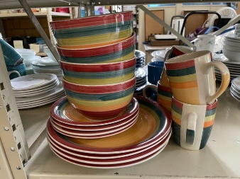
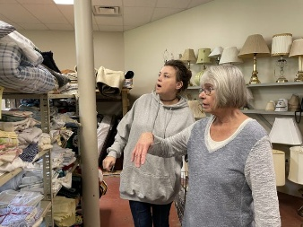
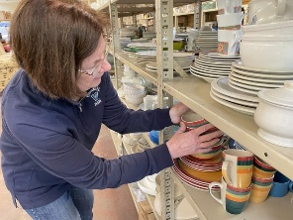
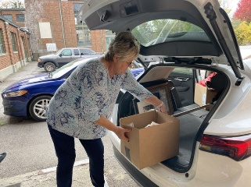
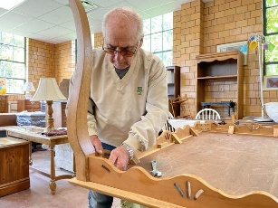
On the day McGlynn visited the ministry, so did Ileene Smith of Monroe. She donated pillows, a table and a couple boxes of kitchenware.

